Java Design Patterns

🧠 1. What is Singleton Design Pattern?
The Singleton pattern is a creational design pattern whose goal is:
👉 Only ONE object of a class should exist in the entire application
👉 Provide a global access point to that object
In simple words:
“One class → Only one object → Everyone uses the same object” a

📦 2. Real-life analogy
Think of:
- Printer spooler → only one manager controls printing
- Database connection → one shared connection
- Logger → one place to log everything
You don’t want multiple instances fighting each other.

public class Singleton {
private static Singleton instance;
private Singleton() {}
public static Singleton getInstance(){
if (instance == null){
return instance = new Singleton();
}
return instance;
}
}

🧠 1. Eager vs Lazy Initialization

⚡ A. Eager Initialization (Simple but rigid)

✅ Idea:
Create the object immediately when class is loaded
public class Singleton {
private static final Singleton instance = new Singleton();
private Singleton() {}
public static Singleton getInstance() {
return instance;
}
}

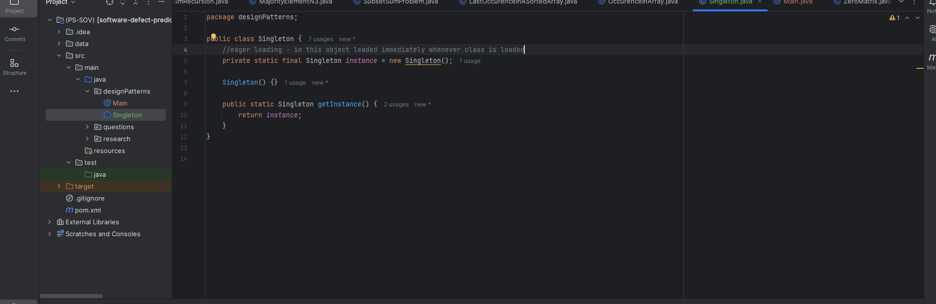

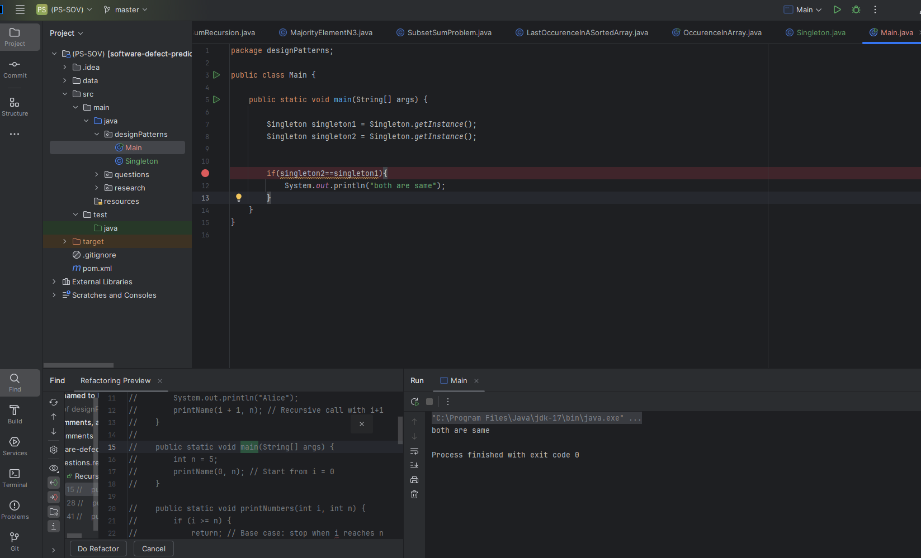

✔ Advantages:
- Thread-safe by default ✅
- Very simple
- No synchronization overhead

❌ Disadvantages:
- Object created even if never used
- Wastes memory if heavy object

📌 When to use:
- When object is lightweight
- When you KNOW it will always be used

🐢 B. Lazy Initialization (Flexible but tricky)

✅ Idea:
Create object only when needed
(Your GitHub code uses this 👇)
public class Singleton {
private static Singleton instance;
private Singleton() {}
public static Singleton getInstance() {
if (instance == null) {
instance = new Singleton();
}
return instance;
}
}
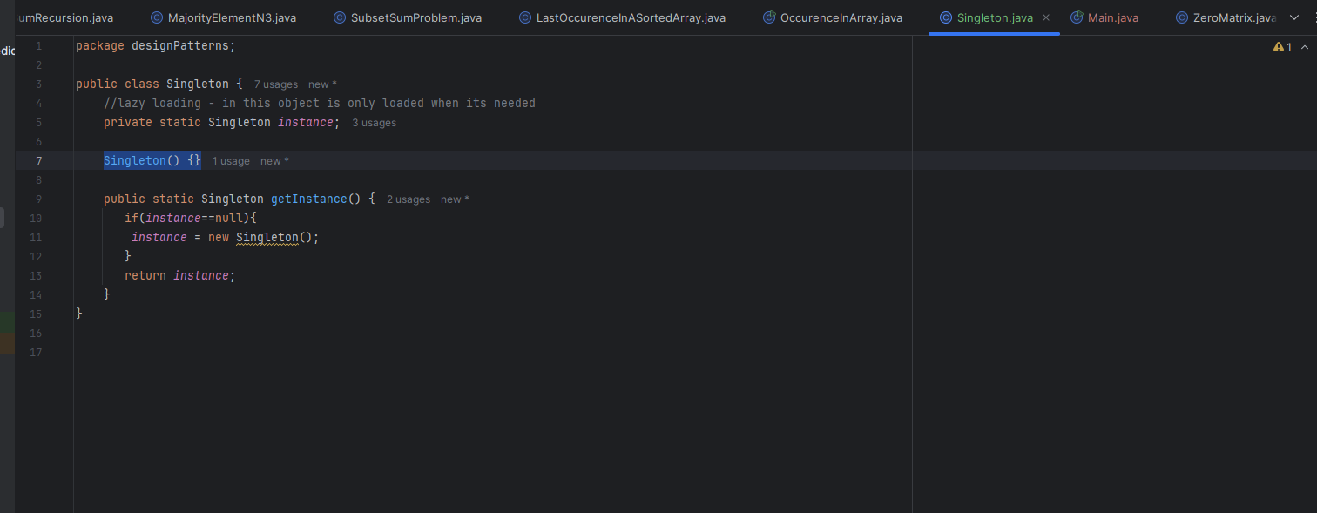

✔ Advantages:
- Saves memory
- Object created only when required

❌ Disadvantages:
- ❌ NOT thread-safe
- Multiple threads can create multiple objects

💥 Problem Example:
Two threads run at same time:
Thread 1 → sees instance == null
Thread 2 → sees instance == null
👉 Both create objects → Singleton BROKEN ❌

🔐 2. Making Singleton Thread-Safe
Now the important part 👇

🧱 Method 1: Synchronized Method (Simple but slow)
public class Singleton {
private static Singleton instance;
private Singleton() {}
public static synchronized Singleton getInstance() {
if (instance == null) {
instance = new Singleton();
}
return instance;
}
}

✔ Pros:
- Easy to implement
- Thread-safe

❌ Cons:
- Slow (every call is locked)
- Performance issue in large systems

⚡ Method 2: Double-Checked Locking (Best practice)
public class Singleton {
private static volatile Singleton instance;
private Singleton() {}
public static Singleton getInstance() {
if (instance == null) {
synchronized (Singleton.class) {
if (instance == null) {
instance = new Singleton();
}
}
}
return instance;
}
}

🧠 Why volatile?
Prevents instruction reordering (very important in Java)

✔ Pros:
- Fast (lock only first time)
- Thread-safe
- Widely used in interviews

🏆 Method 3: Bill Pugh Singleton (BEST & CLEANEST)
public class Singleton {
private Singleton() {}
private static class Helper {
private static final Singleton INSTANCE = new Singleton();
}
public static Singleton getInstance() {
return Helper.INSTANCE;
}
}

🔥 Why this is best:
- Lazy loading ✅
- Thread-safe ✅
- No synchronization overhead ✅
- Uses Java class loader internally

👉 This is industry favorite

🧪 Method 4: Enum Singleton (Ultimate protection)
public enum Singleton {
INSTANCE;
public void show() {
System.out.println("Singleton using Enum");
}
}

✔ Pros:
- Thread-safe by default
- Prevents:
  - Reflection ❌
  - Serialization ❌
- Simplest & safest

❌ Cons:
- Not flexible (cannot extend class)

💥 3. How Singleton Gets Broken
Even if you write Singleton, it can be broken 👇

❌ 1. Reflection Attack
Constructor<Singleton> constructor = Singleton.class.getDeclaredConstructor();
constructor.setAccessible(true);
Singleton s2 = constructor.newInstance();
👉 Creates NEW object 😱

🔐 Fix:
private Singleton() {
if (instance != null) {
throw new RuntimeException("Use getInstance()");
}
}

❌ 2. Serialization Attack
ObjectOutputStream.writeObject(instance);
ObjectInputStream.readObject();
👉 Creates new object

🔐 Fix:
protected Object readResolve() {
return instance;
}

❌ 3. Cloning Attack
Singleton s2 = (Singleton) s1.clone();

🔐 Fix:
@Override
protected Object clone() throws CloneNotSupportedException {
throw new CloneNotSupportedException();
}

🛡️ 4. Best Secure Singleton (Interview-ready)
public class Singleton {
private static volatile Singleton instance;
private Singleton() {
if (instance != null) {
throw new RuntimeException("Use getInstance()");
}
}
public static Singleton getInstance() {
if (instance == null) {
synchronized (Singleton.class) {
if (instance == null) {
instance = new Singleton();
}
}
}
return instance;
}
protected Object readResolve() {
return instance;
}
@Override
protected Object clone() throws CloneNotSupportedException {
throw new CloneNotSupportedException();
}
}

🧠 Final Comparison
Type | Lazy | Thread Safe | Performance | Best Use
Eager | ❌ | ✅ | Fast | Small objects
Lazy (basic) | ✅ | ❌ | Fast | Not recommended
Synchronized | ✅ | ✅ | Slow | Simple apps
Double-check | ✅ | ✅ | Fast | Production
Bill Pugh | ✅ | ✅ | Fastest | Best choice
Enum | ✅ | ✅ | Fast | Maximum safety

🎯 Final Takeaway
If interviewer asks:
👉 Best Singleton?
✔ Say:
- Bill Pugh (practical systems)
- Enum (most secure)

If you want next:
👉 I can explain Factory Pattern from your repo in same depth
👉 Or give interview questions on Singleton

